EU Declaration of Conformity ( CE )

For a medical device class I (according to the EU regulation 2017/745, annex IV)

The manufacturer:

HQI bv | HAIRCAP
Haagstraat 2b / 1
9150 Kruibeke

Declares under sole responsibility, that the class I medical device according to the classification rules of the EU regulation 2017/745, annex VIII

Product code: 890020
Product description: Mobcap Elastan Nonwoven – 250/pack

Complies and meets all the provisions of the conformity assessment procedure of the EU regulation 2017/745 (annex I).

Signed for and on behalf of HQI bv

Kruibeke
01/12/2021

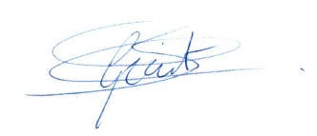

Geert Smet
Head of Quality Management

